Experiment-2

NAME:Karthik V ROLLNO:240701234
DesignaUIwhereusersrecallvisualelements(e.g.,iconsortextchunks).Evaluatetheeffectof chunking on user memory.
FRAME1:
INSTRUCTIONPAGE:

ChunkingAnalysisoftheInstructionPage
Chunkingis a cognitive strategy thatbreaks down information intosmaller,manageable units, makingiteasiertoprocessandretain.TheMemoryRecallTaskinstructionpageeffectivelyutilizes chunking in the following ways:

ClearandSequentialNumbering
  - Theinstructionsarebrokendownintosixsteps,makingiteasiertofollow.
  - Eachsteppresentsonekeyactioninastructuredmanner,reducingcognitive overload.

LogicalGroupingofInformation
  - ObservationPhase(Steps1-2)→Userslearnaboutwhattheywillsee.
  - MemorizationStrategy(Step3)→ Encouragesuserstofocusonrememberingitems.
  - RecallPhase(Steps4-5)→Explainshowuserswillrecallinformation.
  - KeyPerformanceMetric(Step6)→Highlightsthataccuracymattersmorethanspeed.

VisualHierarchyandDesignElements
  - Bold,largetitle("MEMORYRECALLTASK")→ Grabsattentionandclearlystatesthetask.
  - Bulletpointsand spacing→ Reduceclutter,enhancingreadability.
  - Highlighted"START"button→Signalsthenextstep,keepingnavigationintuitive.
  - Bee-themedvisuals→Addaplayfultouch,engaginguserswithoutdistraction.

TimeConstraintReinforcement
  - Step5explicitlystates,“Youwillhave5secondstoviewtheitems.”
  - Thisreinforcesexpectationswhile subtlyurginguserstofocus.

SimplicityandClarity

  - Instructionsuseshort,directsentences,avoidingunnecessarycomplexity.
  - Theactivevoicemakesitmoreengagingandaction-oriented.

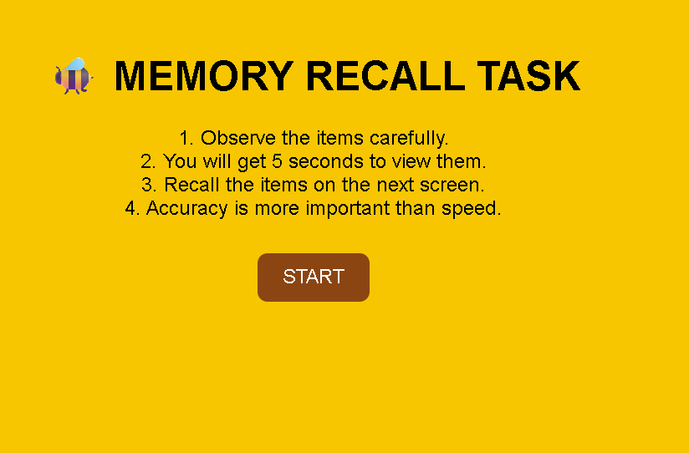
FRAME2:
CHUNKINGPHASE:

AnalysisoftheMemoryRecallTask-ChunkingPhaseScreen
ThisscreenrepresentstheChunkingPhaseofaMemoryRecallTask,whereusersobserveand memorize different icons within a limited time. Below is a breakdown of its key components:

PurposeoftheScreen
  - Thisisthevisualmemoryencodingphase,whereusersviewandgroupitemsmentally
beforerecallingthem.
  - Theterm"ChunkingPhase"suggeststhatthegameappliesthechunkingprinciple,which helps users remember items by categorizing them into meaningful groups.

KeyElementsandUIComponents

⏳CountdownTimer(TopLeft-RedCircle:"00:05")
  - Indicatesthatusershave5secondstoobserveandmemorizethedisplayeditems.
  - Thebrightredcolorandboldtext createurgency,ensuringusersstayfocused.

ProgressBar(PinkBarBelowTitle)
  - Showsthetimeremainingvisually,reinforcingthesenseofurgency.
  - Apartiallyfilledbarsuggeststhatsometimehasalreadypassed.

GridofIcons
  - Variousicons(suchasapig,burger,clock,policecar,arrow,snowman,bee,laughingemoji, etc.) are displayed in a5x4 grid format.
  - Theseiconsarevisuallydistinctyetgroupedbysimilarities,encouragingchunking strategieslike:
    - Categorizingbytheme(e.g.,animals,food,transportation).
    - Groupingsimilarcolorsorbackgrounds(e.g.,pink,blue,oryellowtiles).
    - Associatingrepeatedicons(e.g.,multiplebees,burgers,policecars).

🐝BeeCharacterHoldingaScroll(TopRight)
  - Actsasafriendlymascot,enhancingengagementandgivingaplayfultheme.
  - Thescrollmayimplyinstructionsorguidanceinlaterstages.

HowtheChunkingPhaseWorks
- Usersscanthegridandlookforpatternsorrelateditemstocreatementalchunks.
- Thecountdowntimerlimitsobservationtime,forcingquickmemory strategies.
- Oncetimeisup,userstransitiontotherecallphase,wheretheymustidentifypreviously seen items.

CognitiveandUXBenefitsofChunking
  - Enhancesshort-termmemorybyallowinguserstorecallgroupsofinformationinsteadof individual elements.
  - Reducescognitiveoverloadby helpingusersorganizedataefficiently.
  - Improvespatternrecognition,makingrecalleasierandmoreaccurate.

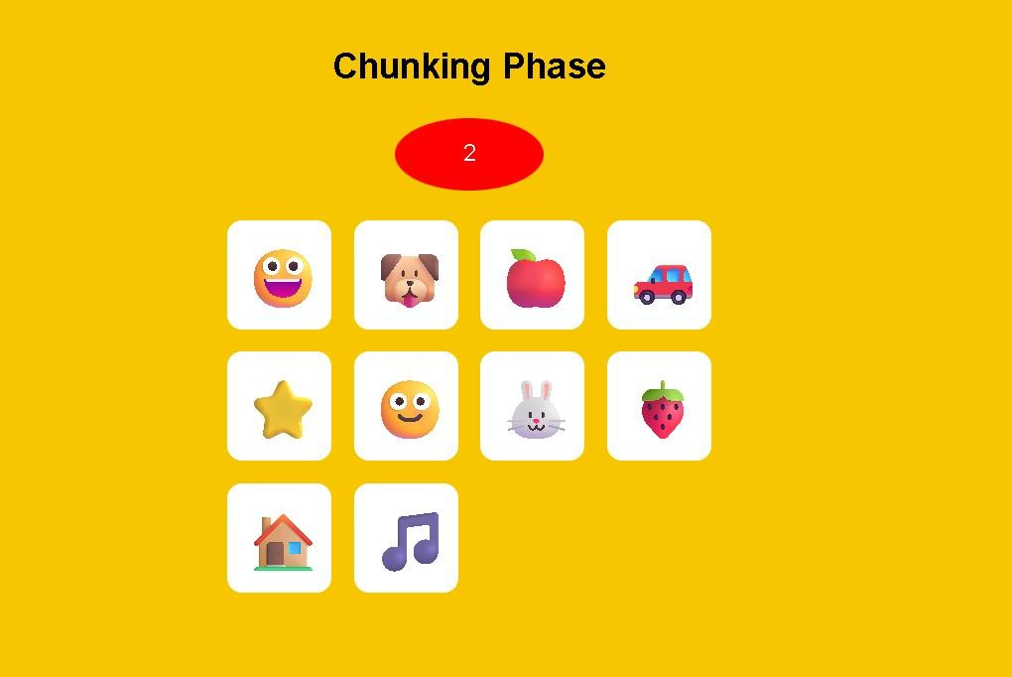
FRAME3:
RECALLPHASE:

AnalysisoftheMemoryRecallTask-SelectionPhase
ThisscreenrepresentstheSelectionPhaseofaMemoryRecallTask,whereusersrecallandchoose the items they remember from the previousChunking Phase. Below is a breakdown of itscomponents:

PurposeoftheScreen
  - Thisisthememoryretrievalstage,whereusersselect theitemstheyrememberseeingin the previous phase.
  - Thegoalistotesttheeffectivenessofchunkingandshort-termmemoryretention.

- KeyElementsandUIComponents
📝Title&Instructions
  - "MEMORYRECALLTASK"(BoldHeader)–Reinforcesthepurposeofthetask.
  - "SELECTTHEITEMSYOUREMEMBER:"–Clearinstructionguidingtheusertochoose remembered items.

GridofIconChoices
  - Asetoftwentyiconsarepresentedasmultiple-choiceoptions.
  - Someiconswerepreviouslydisplayed,whileothersaredistractors(newiconsaddedto confuse users).
  - UsersmustidentifywhichiconsappearedintheChunkingPhase.
  - Eachiconhasaradiobuttonbelowitforselection.

□🐝AnimatedBeeCharacter(BottomLeft)
  - Thebeecharacterreinforcesaplayful,engagingtheme.
  - Itmayactasamascotorguidethroughoutthememorytask.

"SUBMIT"Button(BottomCenter)
  - Onceusershavemadetheirselections,theypress"SUBMIT"toconfirmtheirrecallchoices.

HowtheSelectionPhaseWorks
- UsersanalyzethedisplayediconsandrecallwhichonestheysawintheChunkingPhase.
- Theyselecttherememberediconsusingtheradiobuttonsbeloweachoption.
- Someiconsaredistractors,testingwhethertheuser’s memoryisaccurateorifthey mistakenly recall incorrect icons.
- Clicking"SUBMIT"finalizestheirchoices,leadingtoaresultsorfeedbackscreen.

CognitiveandUXBenefits
  - Testsmemoryaccuracybycomparinguser selectionswithpreviouslydisplayed items.
  - Incorporatesdistractorstoevaluate how wellusers distinguish realvs.false memories.
  - User-friendlyinterfacewith clearselectionmechanics(radiobuttons).
  - Gamifiedelements(bee character,brightcolors)makethetask engaging.

-

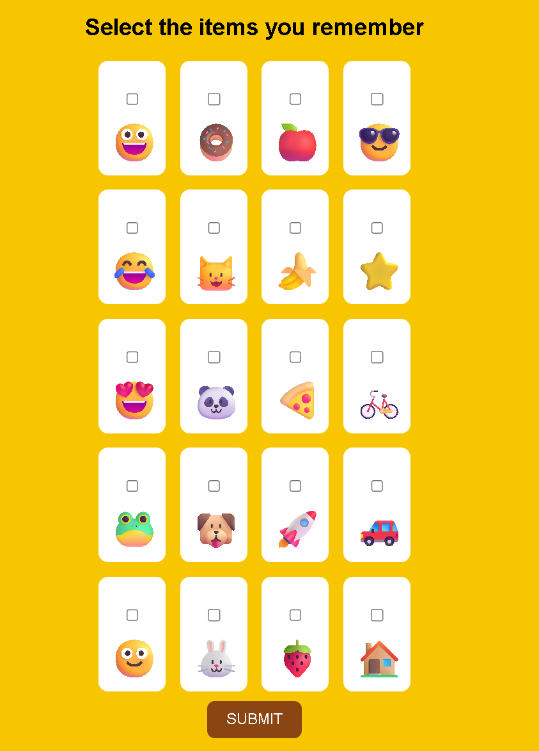
FRAME4:
RESULTPAGE:

AnalysisoftheMemoryRecallTask-Score&FeedbackScreen
ThisscreenrepresentstheScore&FeedbackPhaseoftheMemoryRecallTask,whereusersreceive their performance evaluation based on the selections made in the previousRecall Phase.

PurposeoftheScreen
  - Providesfeedbackonrecallaccuracybyshowingthenumberofcorrectanswers.
  - Allowsuserstodecidetheirnextaction(continue,restart,orexit).

KeyElements&UIComponents
📝Title&ScoreDisplay
  - "MEMORYRECALLTASK"–Reinforcesthe game’s title.
  - "YOURRECALLSCORE!"–Indicatesthattheuser’sperformanceisbeingdisplayed.
  - Awoodenscoreboardwiththeuser’sscore(4/5)inbold,showingcorrectanswersoutof total attempts.

Action Buttons (RightSide)
  - "CONTINUE"–Proceedstothenextlevelorstage.
  - "RESTART"–Allowstheusertoretakethememoryrecalltest.

  - "EXIT"–Endsthetaskandexitsthegame.

🐝AnimatedBeeCharacter(BottomLeft)
    - Thebeecharacteraddsaplayful,gamifiedelement.
    - Holdsablanksign,possiblyfordynamicmessagesoradditionalinstructions.

HowThisPhaseWorks
- Thegameevaluatestheuser’sselectionsfromtheRecallPhase.
- Itcalculatestheaccuracyscore(4/5inthiscase)anddisplaysitonawoodenboard.
- Usersreviewtheirperformanceandchoosetheirnextaction:
  - Continueiftheywanttoproceed.
  - Restartiftheywanttoimprovetheirrecall.
  - Exitiftheywanttostopplaying.

Cognitive&UXBenefits
  - Instantfeedbackhelpsuserstracktheirmemoryperformance.
  - Multipleoptions (Continue,Restart,Exit)giveusers controlover their learningexperience.
  - Visual&gamifiedelementsmakethetaskengagingandlessstressful.

S
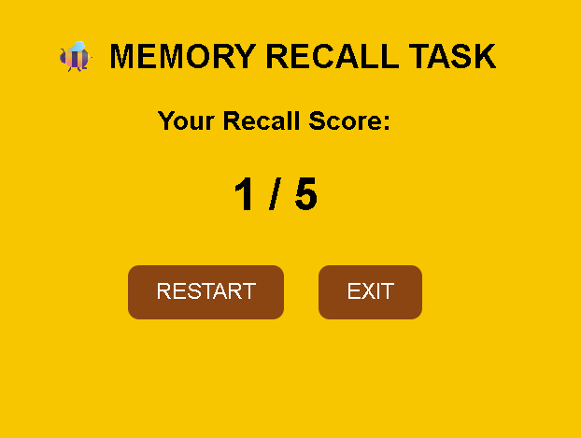

PROTOTYPELINK:
file:///C:/Users/aniru/OneDrive/Desktop/PyProject/index.html

